BIPARTITE GRAPH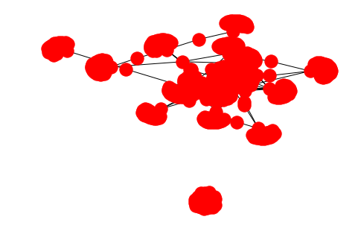

INTRODUCTION:

First we have done it on Psl all four season but now we have done Quaid e azam trophy 2

We have extracted the data from a website:

<https://www.pcb.com.pk/quaideazam-trophy-201819/tournament/1154.html>

BIPARTITE GRAPH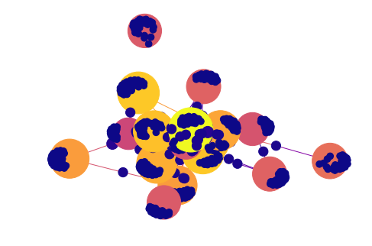

BIPARTITE GRAPH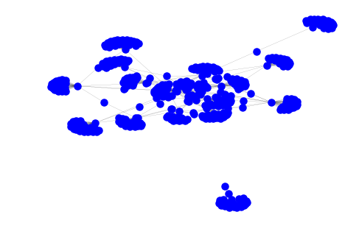

BIPARTITE GRAPH

DESCRIPTION:

Now we have added the both psl and quaid e azam trophy data and made a bipartite graph ……

☺☺☺☺☺☺